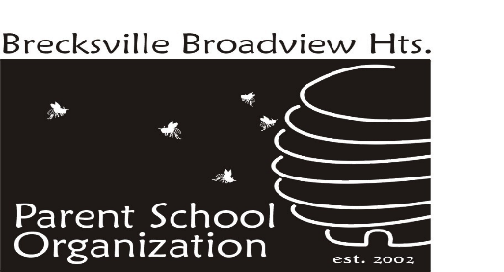

_____________________________________________________________

2023-2024 PSO Year End Recap

Purpose (1.2 Bylaws) - The purpose of the organization shall be to aid all students attending the Brecksville-Broadview Heights City Schools by providing support for their educational, recreational, and social needs and to promote open communication between parents, administration, teachers, and staff.

BBH PSO has had a wonderful year partnering with our schools and families. The past five years presented several challenges to the normal operation of the PSO units. Starting with the unanticipated early closure of Central School and continuing through the pandemic and closure of the district’s three elementaries, the PSO has closed units, transferred funds and resources, consolidated its membership, and developed an entirely new organizational structure at the elementary school, among many other things. Notably, the Elementary PSO unit has successfully expanded its activities to meet the incredible demand at its school. As we conclude the 2023-2024 school year, it is a pleasure to see the PSO and the district itself returning to routine traditional activities.

Total Memberships Sold: 1,455 (214 staff/1,241 families)
Total Funds Raised: $38,301
Total Gifts & Goals: $51,260

2023-2024 PSO Presidents

Council: Denise Gawlik
Elementary School: Mary Green & Vanessa Caslow
Middle School: Petra Laszlo & Joanie MacRaild
High School: Stephanie Baka & Ann Koepke

2024-2025 Incoming PSO Presidents

Council: Mary Green
Elementary School: Vanessa Caslow & Amy Kooser
Middle School: Petra Laszlo & Stacy Lynch
High School: Ann Koepke & Joanie MacRaild

PSO Membership

Elementary School: 783 memberships (112 staff/671 families)
Middle School: 405 memberships (70 staff/335 families)
High School: 267 memberships (32 staff/235 families)

Volunteer Hours (as of 5/13/24)

Council: 1,275
Elementary School: 8,000
Middle School: 1,550
High School: 536

Fundraising

Council: $225 (donations)
Elementary School: 24,000 (No Fuss Fundraiser)
Middle School: $8,716 (No Fuss Fundraiser)
High School: $5,360 (No Fuss Fundraiser)

Gifts & Goals

Elementary School - $25,400
- STEM items:
  - VEX GO Field Tiles for STEAM class
  - Nintendo Pro Controllers (e-sports program)
  - STEM blocks and manipulatives
- Math & Writing material/games
- Musical Enrichment:
  - Basic Beat Resonator Chimes
  - Kleenslates
- Books:
  - Classroom libraries
  - Decodable books for classrooms and specialists
- Individual Dry Erase Boards and Erasers
- Media Center apps
- Privacy Shields
- Headphones
- Sensory items for classroom and specialist use
- Storage items:
  - Seat Sacks for 17 classrooms
  - Under Desk Storage for 5 classrooms
  - Storage pouches
- Preschool enrichment:
  - Sensory Table & Activities
  - STEM manipulatives
  - Adapted Seating Options
Furniture:
- Easels - Double-sided mobile teaching easels
- Flex-space comfy floor seats
- Classroom Carpets

Middle School - $20,500

- Purchased supplies for after school clubs.
- Helped purchase supplies for the jazz band dinner fundraiser.
- Purchased ball room dancing lessons for gym class.
- Purchased wish list items for individual classrooms.
- Purchased a book binding machine for our media center.
- Purchased an outdoor speaker for pep rallies, music performances and other school activities.
- Painting the cafeteria, with assistance from the district.
High School - $5,360

- Purchased security window screening on the high school main entrance, auditorium and gym entrance doors.

This amount reflects the unit’s main fundraiser for the year and does not include amounts received from memberships, spirit wear and other miscellaneous fundraisers.
Gifts & Goals does not reflect amounts spent by individual units to fund their activities.

